Name: _______________________________ Homework: Decimal Place Value #1
Due:
Show all your work in the space provided!
Review
(Remember to show your work! Use the back if necessary.)

34 x 5 = _____________ $\frac{3}{4} + \frac{1}{2} = ________$
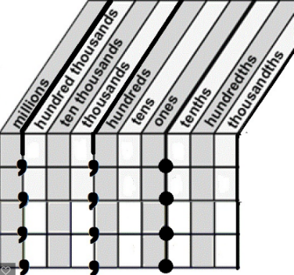
Problem Solving
Put the following numbers in order from least to greatest.
4.674 4.90 4.05 4.104
__________ ___________ __________ __________
Explain how you chose the smallest number: (Use the back if necessary.) ____________________________________________________________________________________________________________________________________________________________________________________________________________________________________________
Build Your Math Skills At Home
5th Grade Website: www.slesgrade5.weebly.com

Optional Skill and Fluency Activities - Websites:
Video for multiplying fractions: http://www.youtube.com/watch?v=d3azHmrqtMU
Websites: www.xtramath.org www.mathplayground.com
http://studyjams.scholastic.com/ www.multiplication.com
http://www.math-play.com www.slesgrade5.weebly.com
Websites/Apps you have tried and would like to recommend:
_______________________________________________________________________________________________________________________________________________________________________________________
Need Help or More Practice? (Optional)

Create a place value chart
Powers of 10
1,000,000 = ${10}^{6}$ = (1 x 1,000,000)
100,000 = ${10}^{5}$ = (1 x 100,000)
10,000 = ${10}^{4}$ = (1 x 10,000)
1,000 = ${10}^{3}$ = (1 x 1,000)
100 = ${10}^{2}$ = (1 x 100)
10 = ${10}^{1}$ = (1 x 10)
1 = ${10}^{0}$ = (1 x 1)
(1 x 0.1) = ${10}^{-1}$ = 0.1
(1 x .01) = ${10}^{-2}$ = 0.01
(1 x .001) = ${10}^{-3}$ = 0.001

Current Study
(Remember to show your work!)
Write the number four hundred fifty-two and nine hundredths in standard form _______________________

Write this expanded form number in standard form:
(5 x 100) + (4 x 10) + $\frac{3}{10}$ + $\frac{2}{100}$ _____________________
What digit has a value 100 times larger than the digit 6 in this number: 12,467 __________

What digit has a value $\frac{1}{10}$ of the digit 6 in the number 12,467? _______

