Name: _______________________________ Homework: Decimal Place Value #2
Due:
Show all your work in the space provided!
Review
(Remember to show your work!)
- 53 ÷ 8 = ________ 3.) 46 x 7 = __________

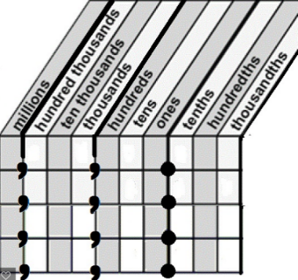
Problem Solving
Stevie has 30 books on shelf. Frank has 100 times the amount of books as Stevie. How many books does Frank have? (Circle your choice.)
3 30 300 3,000
Explain your thinking. Use a place value chart or the back of this sheet.
____________________________________________________________________________________________________________________________________________________________________________________________________________________________________________________________________________________________________________
Build Your Math Skills At Home
5th Grade Website: www.slesgrade5.weebly.com

Dreambox Learning – Please spend a minimum of 30 minutes. This is
in addition to any Dreambox Learning you may do at school in the computer lab.
Username: (5 digit lunch number)
Password: (8 Digit birthday – 2 digit month, 2 digit day, 4 digit year)
www.play.dreambox.com/login/wk7x/stl1
iPad App: School Code – wk7x/stl1

Optional Skill and Fluency Activities - Websites:
Websites: www.xtramath.org www.mathplayground.com
http://studyjams.scholastic.com/ www.multiplication.com
http://www.math-play.com www.slesgrade5.weebly.com
Websites/Apps you have tried and would like to recommend:
______________________________________________________________________________________________________________________________________
Current Study
(Remember to show your work!)
- Put the following in order from least to greatest.
2.54, 2.546, 2.5
__________________________________________________
- What number does the expression represent? (Write in Standard Form)
$$(3 x 100)+(4 x 10)+(5 x 1)+(6 x \frac{1}{10})+(7 x\frac{1}{1000})$$
__________________________________________________
- What is $\frac{1}{10}$ the value of 30,000? ____________
- What is 100 times the value of 4,000? __________
Need Help?
Create a place value chart
Powers of 10
1,000,000 = ${10}^{6}$ = (1 x 1,000,000)
100,000 = ${10}^{5}$ = (1 x 100,000)
10,000 = ${10}^{4}$ = (1 x 10,000)
1,000 = ${10}^{3}$ = (1 x 1,000)
100 = ${10}^{2}$ = (1 x 100)
10 = ${10}^{1}$ = (1 x 10)
1 = ${10}^{0}$ = (1 x 1)
(1 x 0.1) = ${10}^{-1}$ = 0.1
(1 x .01) = ${10}^{-2}$ = 0.01
(1 x .001) = ${10}^{-3}$ = 0.001

