Name: _______________________________ Homework: Decimal Place Value #3
Due:
Show all your work in the space provided!
Review
(Remember to show your work!)
Locate the points on the number line for $4.67 and $4.45.

$4.00 $4.50 $5.00

Use the number line to round to the nearest dollar about.
$4.67 rounds to $__________ $4.45 rounds to $________

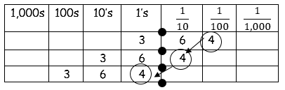
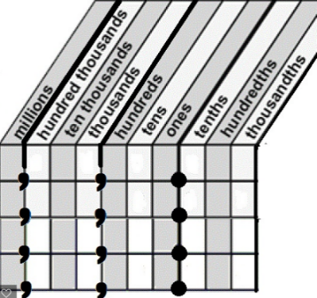
Current Study
(Remember to show your work!)
- Write 24,495.853 in word form:
______________________________________________________________________________________________________________________

- What is 1,000 times the value of 50? _____________________
- What is $\frac{1}{100}$ the value of 5,000? _________________________

Bonus: 34.69 x 100 = ______ (Hint: Look for a pattern on the place value chart in the Problem Solving Section.)
Problem Solving
Explain what you notice about
the value of the 4 in the
numbers 3.64, 36.4, and 364
on the place value chart?
____________________________________________________________________________________________________________________________________________________________________________________________________________________________________________________________________________________________________________
Build Your Math Skills At Home
5th Grade Website: www.slesgrade5.weebly.com

Dreambox Learning –Try to spend a minimum of 30 minutes. This is
in addition to any Dreambox Learning you may do at school in the computer lab.
Username: (5 digit lunch number)
Password: (Your Birthday. If your month is a single digit, then just type 1
digit. Example: January 2, 2006 would be 1022006)
www.play.dreambox.com/login/wk7x/stl1
iPad App: School Code – wk7x/stl1

Optional Skill and Fluency Activities - Websites:
Websites: www.xtramath.org www.mathplayground.com
http://studyjams.scholastic.com/ www.multiplication.com
http://www.math-play.com www.slesgrade5.weebly.com
Websites/Apps you have tried and would like to recommend:
______________________________________________________________________________________________________________________________________
Need Help?
Create a place value chart
Powers of 10
1,000,000 = ${10}^{6}$ = (1 x 1,000,000)
100,000 = ${10}^{5}$ = (1 x 100,000)
10,000 = ${10}^{4}$ = (1 x 10,000)
1,000 = ${10}^{3}$ = (1 x 1,000)
100 = ${10}^{2}$ = (1 x 100)
10 = ${10}^{1}$ = (1 x 10)
1 = ${10}^{0}$ = (1 x 1)
(1 x 0.1) = ${10}^{-1}$ = 0.1
(1 x .01) = ${10}^{-2}$ = 0.01
(1 x .001) = ${10}^{-3}$ = 0.001

