Name: _______________________________ Homework: Module 4 – HW 1
Due:
Show all your work in the space provided!
Review
(Remember to show your work!)
- In the number 386.483 the 8 in the tens place is ______ the value of the 8 in the hundredths place. Circle your choice.
1,000x 100x 10x $\frac{1}{10} \frac{1}{100} \frac{1}{1,000}$
- What is the volume in cubic units of the shape below?

_______ cubic units

- $2\frac{3}{4} -1\frac{1}{4} = ___________$

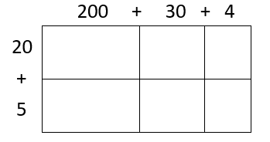
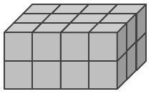
Dreambox Learning
Students should be spending a minimum of 30 minutes per week on Dreambox. If your child has access to internet, please see that he or she gets on Dreambox at home. Your child’s math teacher will be monitoring student time usage, lessons passed, and progress.
www.play.dreambox.com/login/wk7x/stl1
iPad App: School Code – wk7x/stl1

I spent about ___________ minutes on Dreambox this week.
Student Signature: _________________________________

Have you set up parent access to your student’s Dreambox account?
When your student is logged in to Dreambox, see if it says, “Set up Parent Access” in the bottom right corner of their screen. If it does, then click it and set up. If you do NOT see the message, you must have already set up access to your child’s account. If you have trouble gaining access, please contact your child’s math teacher.

Current Study
(Remember to show your work!)
- Use the partial products and area model to solve the problem below.
234 (200 + 30 + 4)
X 25 (20 + 5)
________ (5 x 4)
___________ (5 x 30)
___________ (5 x 200)
________ (20 x 4)
___________ (20 x 30)
+___________ (20 x 200) 2. Now solve 612 x 43. Use both models.
Problem Solving
Henry had a budget of $30.00 to buy dinner. He wanted to order a steak dinner for $14.50, a drink for $2.00 and a dessert for $4.75.
- Does he have enough money in his budget to buy his choices? Y N
How do you know?

- How much under or over budget is he? $_________ Under or Over
How do you know? Budget

