Name: _______________________________ Homework: Volume #1
Due:
Show all your work in the space provided!
Review
(Remember to show your work!)

- 30 x 100 = _______

- 4500 $÷$ 90 = _______

- Round 34.765 to the nearest hundredth: ______

- 65 x 4 = _______

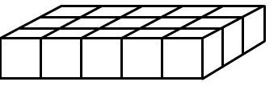
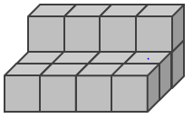
Problem Solving
How many cubic units are in the irregular shape below?
_________cubic units
How many more cubic units would you need to fill in the missing part of the figure below to make it a complete rectangular prism?
__________ cubic units
What would the total number of cubic units
in the complete rectangular prism, be?
______ cubic units

Current Study
(Remember to show your work!)
- What is volume?

- Find the volume of a rectangular prism below.
V = ____ cubic units

The strategy I used to find the number of cubic units was . . .
Dreambox Learning
Students should be spending a minimum of 30 minutes per week on Dreambox. If your child has access to internet, please see that he or she gets on Dreambox at home. Your child’s math teacher will be monitoring student time usage, lessons passed, and progress.
www.play.dreambox.com/login/wk7x/stl1
iPad App: School Code – wk7x/stl1

I spent about ___________ minutes on Dreambox this week.
Student Signature: _________________________________

Have you set up parent access to your student’s Dreambox account?
When your student is logged in to Dreambox, see if it says, “Set up Parent Access” in the bottom right corner of their screen. If it does, then click it and set up. If you do NOT see the message, you must have already set up access to your child’s account. If you have trouble gaining access, please contact your child’s math teacher.

