Name: _____________________________ Homework: Coordinate Graphing #1
Due:
Show all your work in the space provided!
Review
(Remember to show your work!)
- 400 is ________ the value of 40,000 - Circle the correct answer. $\frac{1}{10} \frac{1}{100} 10x 100x$

- 70 is ________ the value of 0.7 - Circle the correct answer. $\frac{1}{10} \frac{1}{100} 10x 100x$

- Heather and Jamie were trying to solve 4.5 $÷ 100.$
Heather’s Answer Jamie’s Answer
0.045 450

Who’s right? Explain. _____________________________________________________________________
_______________________________________________________________________________________
Current Study
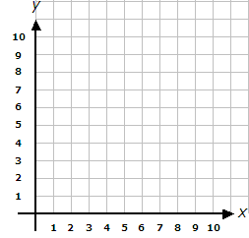
- Draw an arrow and label the origin.

- Plot the follow coordinates and label their points with the letter.
A (3,5) B (5,5) C (7, 5) E

- List the x coordinates from #2: _____, _____, _____
- How did the x coordinate change each time? Look for a pattern. F
_______________________________

- What are the coordinates for each point?
E (____,____) F (____,____)

Problem Solving
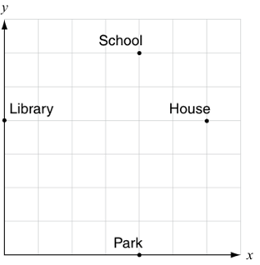
Using the map, Holly wants to give her friend directions to her house from the school. Tell how she should get from the school to her house.
Starting at the school . . .
_______________________________________________________________
_______________________________________________________________
End at my house. Word Bank Suggestions:
up down over left right units x-axis y-axis
Build Your Math Skills At Home
5th Grade Website: www.slesgrade5.weebly.com
Dreambox Learning –Students should be spending at least 90 minutes per week and completing 7 or more lessons each week. iPad App: School Code – wk7x/stl1

