Name: _______________________________ Homework: Dividing Decimals #1

Due:

**Show all your work in the space provided!**

Review

(Remember to show your work!)

1. $\frac{1}{4} ÷ 2= ______$ 2. $4\frac{1}{2} x 1\frac{3}{4} = _____$ (Hint: change the

mixed numbers to improper fractions then

multiply.)

3.) 5.27 x .6 = ___________ (Hint: How many place values are less than a whole?)

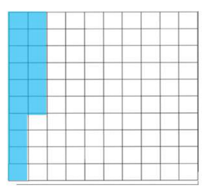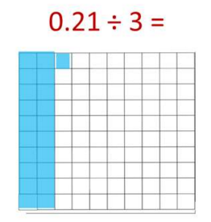

Current Study

(Remember to show your work!)

Divide. Use the strategies to help you.

0.21 $÷3= ______$ 0.16 $÷ 0.04= _________$

(Hint: How many hundredths would be in 3 equal groups?) (Hint: How many equal groups of 0.04 can be made?)

Circle the groups. Circle the groups.

4.5 $÷$.5 = ________ 2.40 $÷ .06= __________$

$\frac{4.5 x 10}{.5 x 10}$ = $\frac{45}{5}=$ $\frac{2.40 x 100}{.06 x 100}$ = $\frac{240}{6} =$

Problem Solving

1. John paid $6.90 for 3 plants. How much did each plant cost? ___________ (Check: 3 x ________ = 6.90)
2. The girls’ basketball coach had the team run 2.4 miles during practice. If each lap around the track is 0.04 miles, how many laps did the team run? Use the grid below to help solve using a model. ________ laps (Check: 0.04 x ______ laps = 2.4)

Use a strategy – using fractions or make a model.

Build Your Math Skills At Home

5th Grade Website: [www.slesgrade5.weebly.com](http://www.slesgrade5.weebly.com)

**Must Do:**

**Dreambox Learning** – Complete at least 5 lessons this week**.**

[www.play.dreambox.com/login/wk7x/stl1](http://www.play.dreambox.com/login/wk7x/stl1)

**iPad App:** School Code – wk7x/stl1