Name: _______________________________ Homework: Measurement #1
Due:
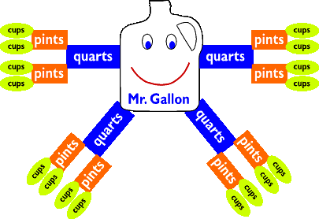
Show all your work in the space provided!
Metric Units Current Study Standard Units
(Remember to show your work!)

3) 5 m = __________cm 9) 5 yd = __________ft

4) _________m = 2 km 10) 60 in =_________ft

5) 4,000 m = ________km 11) 4 lb = ________oz

7) 8 kL = ___________L 12) ________qt = 3 gal

8) 1.5 kg = ____________g 13) 7 pt =________qt

Fraction Review
- Fill in the blank to make an equivalent fraction. Then, prove it with 2) Write the decimal equivalent.
an equation or model (picture) in the space provided.
- $\frac{2}{3}$ = $\frac{}{9}$ B. $\frac{6}{}$ = $\frac{3}{4}$ A. $\frac{36}{100}$ = ________

$B. \frac{9}{10}$ = _________
C. 4 $\frac{7}{100}$ = ________
C. $\frac{3}{10}$ = $\frac{}{100}$ D. $\frac{3}{10}$ + $\frac{4}{100}$ = ----- D. 72 $\frac{546}{1000}$ =________
(Hint: Use C to help solve D.)
Problem Solving
14) Use the Tasty Treats ad to solve. Cameron needs 1 gallon of ice cream for a party. Highlight the best buy, then explain your choice.

1 gallon for $2.79!
Two 1-quart containers for $1.00!

Challenge: (Optional, but try it!)

A. Josh began doing his chores at 3:30 p.m. He finished at 4:45 p.m. How many minutes did it take him to finish his chores?

B. Taylor needs to practice her violin for 45 minutes, then Dreambox for 20 minutes. If she begins at 11:20 a.m., at what time will she finish?

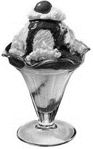
Tasty Treats

Ice Cream Sale!
Using Technology to Improve Your Math Skills…

As license provider, CCPS expects all students to spend at least 90 minutes per week trying to pass at least 7 lessons. We check reports together as a class each week. Meeting this goal earns you a clip up!

XtraMath
Have you placed out?
Yes? Fabulous!
No? Practice, then, every day at least once a day on this program. (about 7 minutes)

slesgrade5.weebly.com
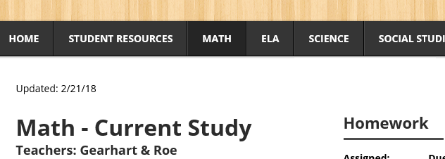
[Thanks, Mrs. Gearhart, for creating this awesome resource and keeping it current!]

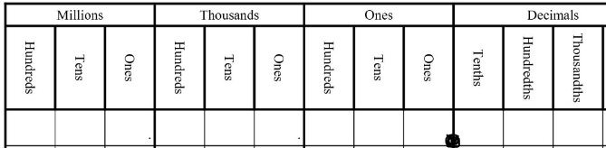
Here you’ll find: games, video tutorials, practice, tips and hints on our current unit of study as well as MUCH information on past units
Metric Conversions Standard Conversions
Linear / Length Capacity Weight (mass)
10 cm = 1 mm (liquid volume) 1000 g = 1 kg
100 cm = 1 m 1 L = 1000 mL
1000 m = 1 km

Linear / Length Capacity Weight (mass)
12 in = 1 ft 8 fl oz = 1 c 16 oz = 1 lb
3 ft = 1 yd 2 c = 1 pt 2000 lbs = 1 T
36 in = 1 yd 2 pt = 1 qt
4 c = 1 qt
4 qt = 1 gal

