Name: _______________________________ Homework: Module 10 - Dividing Fractions #1
Due:
Show all your work!
Review
(Remember to show your work!)
- $\frac{3}{4} x \frac{2}{3}= _________$

- H= 20 in L = 10 in W= 4 in Volume = _________ cubic inches

- 5 + 15 ÷ 3 - 6 = ________

- 57.4 ÷ 10 = ________

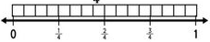
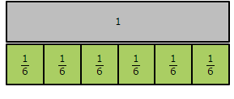
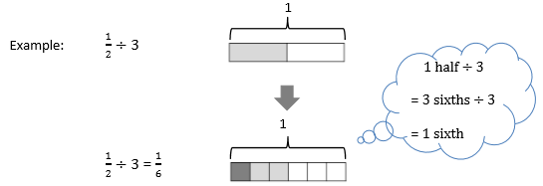
Challenge: (Optional)
There are 3 rectangular prisms that have a TOTAL volume of 726 cubic meters and each of the prisms have the same volume. If there was a box that was $\frac{1}{2}$ the size of one of the rectangular prisms, what would its volume be?

Problem Solving
- Donnie has a jar of 9 whole pickles. The label says that a serving size is ¼ of a whole pickle. How many servings can Donnie get out of his jar of pickles?

- Tasha eats half her snack and gives the other half to her two best friends for them to share equally. What portion of the whole snack does each friend get?
Build Your Math Skills At Home
5th Grade Website: www.slesgrade5.weebly.com

www.play.dreambox.com/login/wk7x/stl1
iPad App: School Code – wk7x/stl1
Current Study
(Remember to show your work!)

Divide. Use the models to help you. (Hints: How many groups can be made?) Rules: Whole Number ÷ Fraction = Whole Number
Fraction ÷ Whole Number = Fraction

How many groups of $\frac{1}{6}$ can you count? What is 1 fraction of the whole?
1 $÷ \frac{1}{6} = _____$ $\frac{1}{4} ÷ 4 ________$

Solve: $\frac{1}{3} ÷2= ________$ 5 ÷ $\frac{1}{2}= ______$ $\frac{1}{6} ÷3= ______$

