Name: _______________________________ Homework: Module 11 - Volume
Due:
Show all your work!
Review
(Remember to show your work!)
- 54.54 The 5 in the tenths place is ( 100x, 10x, $\frac{1}{10} , \frac{1}{100} )$the value of the 5 in the tens place.

2. Round 346.548 to the nearest tenth. ____________

3. $\frac{1}{3} ÷ 6 = ________$ 4. $\frac{3}{4} of 12 = ______$

5. ${10}^{3} = ________________$
Problem Solving
(Remember to show your work!)
(V = B x H [Base = L x W] or V = L x W x H)

- A suitcase is 8 inches high and has a total volume of 320 cubic units. What would the length be if the width is 10 inches? Draw a diagram to help. Length = _________ inches

- Mr.Gross built two storage bins for his sister. The volume of the larger rectangular prism is 100 cubic feet. The dimensions of the smaller rectangular prism are 3 feet by 3 feet by 3 feet. What is the total volume of the bins? ________
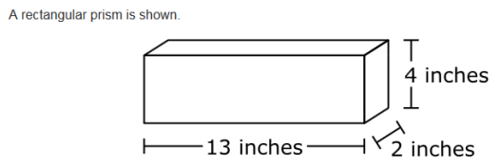
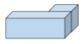
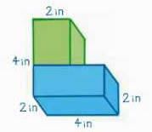
Current Study
(Remember to show your work!)
(V = B x H [Base = L x W] or V = L x W x H)

_________ cubic inches

What is the total volume? ______$cubic inches$
Build Your Math Skills At Home
5th Grade Website: www.slesgrade5.weebly.com
Students should be completing . . .
- 5 or more lessons per week.
- assigned lessons from the teacher before doing free choice lessons.

www.play.dreambox.com/login/wk7x/stl1
iPad App: School Code – wk7x/stl1

How many lessons can you pass in a week? If you pass 5 or more you will get your picture on the Dreambox Shoutout Bulletin Board!
Have you set up parent access to your student’s Dreambox account?
When your student is logged in to Dreambox, see if it says, “Set up Parent Access” in the bottom right corner of their screen. If it does, then click it and set up. If you do NOT see the message, you must have already set up access to your child’s account. If you have trouble gaining access, please contact your child’s math teacher.

