Name: _______________________________ Homework: Module 4 – HW 2
Due:
Show all your work in the space provided!
Review
(Remember to show your work!)
- In the number 459.594 the 9 in the hundredths place is ______ the value of the 9 in the ones place. Circle your choice.
1,000x 100x 10x $\frac{1}{10} \frac{1}{100} \frac{1}{1,000}$
- What is the volume in cubic units of the shape below? (Hint: each level is different.)

_______ cubic units

- $5\frac{1}{2} +2\frac{2}{4} = ___________$

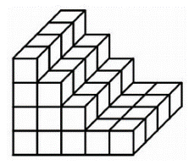
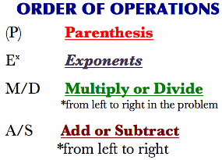
Problem Solving
Show your work!
Jamie earned $23.00 for cutting grass. She went to Walmart and wanted to buy a shirt for $7.50, earbuds for $6.00, and a game for $12.50.
How much would all 3 items cost? $_________

Is the total great than, less than, or equal to $23.00? ______________
What is the difference between the total cost and $23.00? $_________
Dreambox Learning
Students should be spending a minimum of 30 minutes per week on Dreambox. If your child has access to internet, please see that he or she gets on Dreambox at home. Your child’s math teacher will be monitoring student time usage, lessons passed, and progress.
www.play.dreambox.com/login/wk7x/stl1
iPad App: School Code – wk7x/stl1

I spent about ___________ minutes on Dreambox this week.
Student Signature: _________________________________

Have you set up parent access to your student’s Dreambox account?
When your student is logged in to Dreambox, see if it says, “Set up Parent Access” in the bottom right corner of their screen. If it does, then click it and set up. If you do NOT see the message, you must have already set up access to your child’s account. If you have trouble gaining access, please contact your child’s math teacher.

Current Study
(Remember to show your work!)
Use partial product, area model, OR standard algorithm to solve the problems below. Use scratch paper if necessary.

- 453 x 72 = _________ 2. 826 x 23 = ___________

Use the order of operations to solve.

- 3 + (4 x 2) – 5 + (10 $÷$ 5) = ______

- 5 + 20 ÷ 4 – 2 = _________

