Name: _______________________________ Homework: Module 4 – HW 3
Due:
Show all your work in the space provided!
Review
(Remember to show your work! Use a scratch piece of paper if necessary.)

- 3456 2. 7351 3. 4000
+ 389 - 564 -3456

Round 367.46 to the nearest tenth ______________

1 meter = ________ centimeters

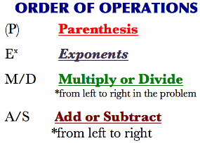
Problem Solving
Show your work!

A swimmer finished his 2nd lap in 15.432 seconds. His 1st lap was 2.546 seconds faster than the 2nd lap. How many seconds was his first lap? ___________ seconds (Show your work.)
Dreambox Learning
Students should be spending a minimum of 30 minutes per week on Dreambox. If your child has access to internet, please see that he or she gets on Dreambox at home. Your child’s math teacher will be monitoring student time usage, lessons passed, and progress.
www.play.dreambox.com/login/wk7x/stl1
iPad App: School Code – wk7x/stl1

I spent about ___________ minutes on Dreambox this week.
Student Signature: _________________________________

Have you set up parent access to your student’s Dreambox account?
When your student is logged in to Dreambox, see if it says, “Set up Parent Access” in the bottom right corner of their screen. If it does, then click it and set up. If you do NOT see the message, you must have already set up access to your child’s account. If you have trouble gaining access, please contact your child’s math teacher.

Current Study
(Remember to show your work!)
Use partial product, area model, OR standard algorithm to solve the problems below. Use scratch paper if necessary.

- 366 x 45 = _________ 2. 672 x 56 = ___________

Use the order of operations to solve.

- $4 + 3^{2}$ - (2 x 3) = _________

- 6 + 45 ÷ 5 – 4 x 3 = _________
(Exponent: a power to which a number is multiplied by itself. Example$2^{3}=2 x 2 x 2=8$)

