Name: ________________________________________ Test Review: Module 4
Date: ______________________________ Test Date: __________

- 574
X 72

- 863 x 237 =
- 9.63 + 6.8 =

- Evaluate.
[(6 x 4) - (8 – 2)] + 7 =

- Write an expression to solve the difference of 8 and 5 then add the sum of 4 and 7.

6) Which expression represents the calculations described below?
Subtract 3 from 7, then multiply the difference by 5.

A 5 x 7 – 3
B 7 – 3 x 5
C 5 x (7 - 3)
D (7 x 5) - 3
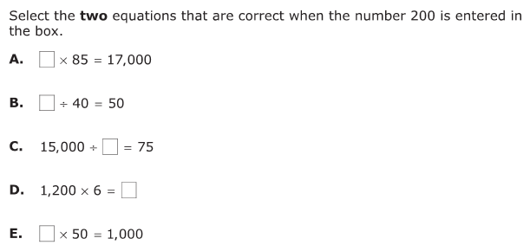
7)

8) Look at the expression.
9(5 + 4) ÷ 3 + 6
What is the value of the expression? Show your work or explain your thinking.

9) Henry had a board that measures 8 feet. He needed to cut it to a length of 5.65 feet. How much will he need to cut from the board? _____ft

10) 3254
X 68

