Name: _______________________________ Homework: Module 7 Division - #2
Due:
Show all your work!
Review
(Remember to show your work!)
Solve. (Hint: Use LCM to find a common denominator and make equivalent fractions.)
- 5$\frac{3}{8} + 6\frac{1}{3}$ = _______ 2. 3$\frac{1}{5} - 1\frac{1}{10}$ = _________

- $4,000-3,453= ________$ 4. 75 + 44.36 = __________
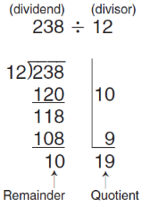
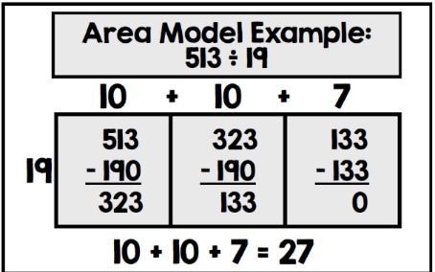
Current Study
(Remember to show your work!)
Use partial quotients or area/box model.
- 2400 ÷ 40 = ______
- 3400 ÷ 20 = ______
- 643 ÷ 80 = ______
Dreambox Learning
Students should be completing . . .
- 5 or more lessons per week.
- assigned lessons from the teacher before doing free choice lessons.

www.play.dreambox.com/login/wk7x/stl1
iPad App: School Code – wk7x/stl1

How many lessons can you pass in a week? If you pass 5 or more you will get your picture on the Dreambox Shoutout Bulletin Board!
Have you set up parent access to your student’s Dreambox account?
When your student is logged in to Dreambox, see if it says, “Set up Parent Access” in the bottom right corner of their screen. If it does, then click it and set up. If you do NOT see the message, you must have already set up access to your child’s account. If you have trouble gaining access, please contact your child’s math teacher.

Problem Solving
(Show your thinking. If you use mental math, what strategy did you use?)

Terry says the solution to 299 ÷ 40 is 6 with a remainder of 59. His work is shown below. Explain Terry’s error in thinking, and then find the correct quotient using the space on the right.

