Name: _______________________________ Homework: Module 7 – Multiplying Fractions #1
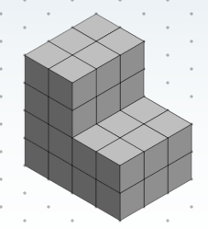
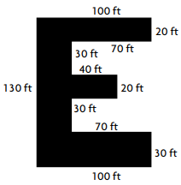
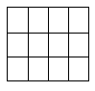
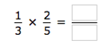
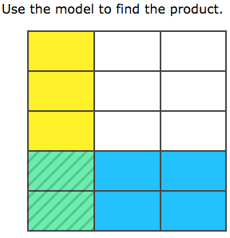
5th Grade Website: www.slesgrade5.weebly.com
Challenge (Optional)

Problem Solving -Show your thinking.
- Sammy wants to plant corn in his garden that will be $\frac{2}{3}$ of the length of the garden and $\frac{3}{4}$ of the width of the garden. What will the total area of the garden be that he wants to plant with corn? (Area = L x W)

- Three-fourths of a pan of brownies was sitting on the counter. You decided to eat 1/3 of the brownies in the pan. How much of the whole pan of brownies did you eat?
Use the model to show a part of a part.
$$\frac{1}{3} of \frac{3}{4}$$

Current Study
(Remember to show your work!)

- 2. $\frac{3}{5} of 20= ______$

$3. 12 × \frac{3}{4} = _______$

4. . $\frac{2}{3} x \frac{3}{4}= _____$

Due:
Review
(Remember to show your work!)
- What is the total volume of the rectangular prisms below?
_______ ${cm}^{3}$

- $310.15 - $27.30 = ________

- $4\frac{3}{5} + 5\frac{2}{3} = ________$ 4. $3\frac{1}{2} -1\frac{3}{8}$ = _______

