Name: _______________________________ Homework: Module 8 – Multiplying Fractions #2
Due:
Show all your work!
Review
(Remember to show your work!)
- What is the total volume of the rectangular prisms below?
_______ ${cm}^{3}$

- $310.15 - $27.30 = ________

- $4\frac{3}{5} + 5\frac{2}{3} = ________$ 4. $3\frac{1}{2} -1\frac{3}{8}$ = _______
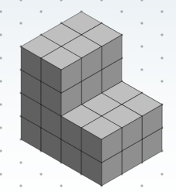
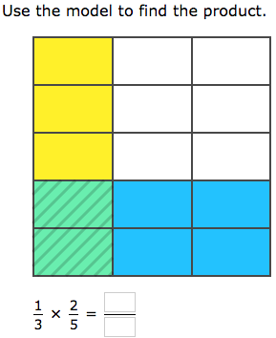
Current Study
(Remember to show your work!)

- 2. $\frac{3}{5} of 20= ______$

$$3. 12 × \frac{3}{4} = _______$$

4. $\frac{2}{3} x \frac{3}{4}= _____$
Build Your Math Skills At Home
5th Grade Website: www.slesgrade5.weebly.com
Dreambox Learning
Students should be completing . . .
- 5 or more lessons per week.
- assigned lessons from the teacher before doing free choice lessons.

www.play.dreambox.com/login/wk7x/stl1
iPad App: School Code – wk7x/stl1

How many lessons can you pass in a week? If you pass 5 or more you will get your picture on the Dreambox Shoutout Bulletin Board!
Have you set up parent access to your student’s Dreambox account?
When your student is logged in to Dreambox, see if it says, “Set up Parent Access” in the bottom right corner of their screen. If it does, then click it and set up. If you do NOT see the message, you must have already set up access to your child’s account. If you have trouble gaining access, please contact your child’s math teacher.

Problem Solving
- Sammy wants to plant corn in his garden that will be $\frac{2}{3}$ of the length of the garden and $\frac{3}{4}$ of the width of the garden. What will the total area of the garden be that he wants to plant with corn?

- 3/4 of a pan of brownies was sitting on the counter. You decided to eat 1/3 of the brownies in the pan. How much of the whole pan of brownies did you eat?

