Name: _______________________________ Homework: Multiplying Fractions and Decimals
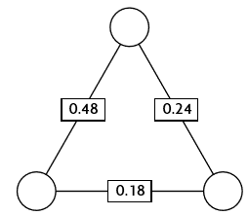
Show all your work!
Challenge (Optional - Bonus)

The numbers in the squares are the products of the numbers in the circles. Find the missing numbers.
Current Study
Remember to show your work! Use scratch paper if necessary.

- 4 x 0.5 = _______ or 4 x $\frac{5}{10}= ______$

- 0.3 x 0.6 = ______ or $\frac{3}{10 } x \frac{6}{10}= ______$

- 0.07 x 0.9 = ______ or $\frac{7}{100} x$ $\frac{9}{10} = ______$
Problem Solving
Show your work! Use a scratch piece of paper if necessary.

- Kayla has $5.50. Liam has 4 times has much money. How much money does Liam have?

2,
Review
Remember to show your work! Use a scratch piece of paper if necessary.

- 345 $÷$ 42 = ________ 2.) 623 x 48 = ____________

- Write $2$ x ${10}^{5}+5$ x ${10}^{3}+8 x {10}^{2}+4 x {10}^{1}+9 x {10}^{0}+6 x \frac{1}{10}+3 x \frac{1}{100}$ in standard form. _______________________________

